SOFTWARE PROJECT MANAGEMENT– MG6088
GATE Questions

Q 1: Tool used for secure expert judgment
A. Peer Review
B. Delphi Technique
C. Expected value technique
D. Work Breakdown Structure (WBS)

Q2.
A company needs to develop a strategy for software product development for which it has a choice of two programming languages L1 and L2. The number of lines of code (LOC) developed using L2 is estimated to be twice the LOC developed with Ll. The product will have to be maintained for five years. Various parameters for the company are given in the table below.
Parameter | Language L1 | Language L2
Man years needed for development | LOC/10000 | LOC/10000
Development cost per man year | Rs. 10,00,000 | Rs. 7,50,000
Maintenance time | 5 years | 5 years
Cost of maintenance per year | Rs. 1,00,000 | Rs. 50,000
Total cost of the project includes cost of development and maintenance. What is the LOC for L1 for which the cost of the project using L1 is equal to the cost of the project using L2?
(A) 4000
(B) 5000
(C) 4333
(D) 4667

Q3.
Match the problem domains in GROUP I with the solution technologies in GROUP II
GROUP I GROUP II
(P) Service oriented computing (1) Interoperability
(Q) Heterogeneous communicating systems (2) BPMN
(R) Information representation (3) Publish-find-bind
(S) Process description (4) XML

Q4.
1) Waterfall model a) Specifications can be
developed incrementally

2) Evolutionary model b) Requirements compromises
are inevitable

3) Component-based c) Explicit recognition of risk
software engineering

4) Spiral development d) Inflexible partitioning of
the project into stages

Q5.

A project consists of 14 activities, A to N. The duration of these activities (in days) are shown in brackets on the network diagram. The latest finish time (in days) for node 10 is __________
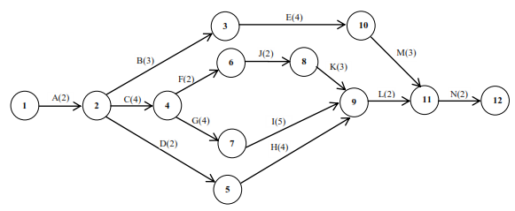

Q6.
Following data refers to the activities of a project , where, node 1 refers to the start and node 5 refers to the end of the project.
Activity | Duration (days)
1-2 | 2
2-3 | 1
4-3 | 3
1-4 | 3
2-5 | 3
3-5 | 2
4-5 | 4
The critical path (CP) in the network is
-  (A) 1-2-3-5(B) 1-4-3-5
- (C) 1-2-3-4-5 (D) 1-4-5
Q7.
Which of the following is not considered as a risk in project management?
a) Specification delays
b) Product competition
c) Testing
d) Staff turnover

Q8.
The precedence relations and duration (in days) of activities of a project network are given in the table. The total float (in days) of activitiese and f , respectively, are
Activity | Predecessors | Duration (days)
a | - | 2
b | - | 4
c | a | 2
d | b | 3
e | c | 2
f | c | 4
g | d,e | 5
(A) 0 and 4 
(B) 1 and 4
(C) 2 and 3
(D) 3 and 1

Q9.
Which of the following is a project scheduling method that can be applied to software development?

a) PERT
b) CPM
c) CMM
d) Both PERT and CPM

Q10.
Consider the following PERT network:
The optimistic time, most likely time and pessimistic time of all the activities are given in the table below

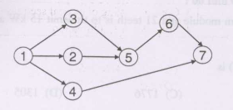

Activity Optimistic time (days) Most likely time (days) Pessimistic time (days)
1-2 1 2 3
1-3 5 6 7
1-4 3 5 7
2-5 5 7 9
3-5 2 4 6
5-6 4 5 6
4-7 4 6 8
6-7 2 3 4
The critical path duration of the network (in days) is
- (A) 11(B) 14
(C) 17

- (D) 18

Q11.
A technique for performing quantitative analysis of progress is known as
a) BCWS
b) EVA
c) BAC
d) CBSE

Q12.
A project usually has a timeline chart which was developed by
a) Henry Gantt
b) Barry Boehm
c) Ivar Jacabson
d) None of the mentioned

Q13.
Which of the following uses empirically derived formulas to predict effort as a function of LOC or FP?
a) FP-Based Estimation
b) Process-Based Estimation
c) COCOMO
d) Both FP-Based Estimation and COCOMO
Q14.
Identify the disadvantage of Spiral Model.
a) Doesn’t work well for smaller projects
b) High amount of risk analysis
c) Strong approval and documentation control
d) Additional Functionality can be added at a later date

